NMIMS, NSOMASA . MLOPS . PROJECT 4 . CAPSTONE

End to End MLflow
Pipeline

One automated pipeline that takes raw data to a live, monitored model,
and fails safely when something goes wrong.

A reproducible MLOps build with Prefect, MLflow, FastAPI, Prometheus and Grafana.

4,000  training listings | 0.81  holdout R2 | 9.59  RMSE in lakhs | 8  automated stages

REPORT DETAILS:
ASSESSMENT | Project 4, Capstone: End to End MLflow Pipeline
GITHUB REPO LINK | https://github.com/devikajonjale/Capstone-End-to-End-MLflow-Pipeline-from-Raw-Data-to-Monitored-Deployment
COURSE | Machine Learning Operations (MLOps)
SUBMITTED BY | Devika Jonjale (B045) and Saachi Shinde (B048)
INSTITUTE | NSOMASA, NMIMS
DATASET | Capstone house prices: 4,000 training, 1,500 incoming (3 batches)
TOOLS | Python, MLflow, Prefect, FastAPI, Prometheus, Grafana, Docker
DATE | October 2026

PROJECT WORKFLOW
01  Ingest | 02  Validate | 03  Features | 04  Train | 05  Evaluate | 06  Register | 07  Serve | 08  Monitor

Table of Contents

Executive Summary 4
01 Problem and Objectives 4
Success metrics, chosen and justified 5
Non functional requirements 5
02 Architecture and Tools 5
Tools, and the one substitution 6
03 Configuration, Code and Data Management 7
04 The Data 7
Data dictionary 7
Data quality and how the batches drift 8
05 Pipeline Design and Orchestration 8
The training flow, drawn 8
Stage inputs, outputs and re-runnability 9
06 Feature Engineering 9
Derived features 9
Preprocessing built into the model 9
What drives the predicted price 10
07 Model Training and Tuning 10
08 Validation Gates and Safe Failure 11
The data gate 11
The model gate, as a decision 12
Two demonstrated failures (real output) 12
09 Tracking, Registry and Lineage 12
Lineage from the deployed model 13
10 Serving the Model 13
11 Monitoring and Drift Detection 16
Per feature PSI over the three batches 16
Performance drift and the alert decision 16
What happens when an alert fires 16

12 CI, Release and Rollback 17
Pull request checks 17
Release on merge 17
Rollback 18
13 Containerised Deployment and Dashboards 19
How the stack connects 19
14 Worked Example: One Full Run 20
Step 1. Train and promote the first model 20
Step 2. Serve a quote 20
Step 3. New batches arrive and are monitored 20
Step 4. A bad batch is refused 21
Step 5. Ship a change safely 21
15 Results, Contributions and Reflection 21
Rubric coverage 21
Individual contributions 21
Reflection: what we would improve with more time 22
Reproducibility 22

Executive Summary
A real estate analytics start up quotes asking prices for property listings in lakhs of rupees. New batches of listings arrive regularly, and until this project every retraining and release was done by hand, with no record of which data, code or configuration produced a given model. That makes results impossible to reproduce and makes it dangerously easy to push a worse model into production.
This project replaces that manual routine with one automated pipeline that carries raw data all the way to a live, monitored prediction service and, just as importantly, fails safely. Data moves through ingestion, a data quality gate, feature engineering, training, a model quality gate, registration and promotion, serving and monitoring.
Two gates protect the production model: a data gate rejects a batch whose schema, missing value share or value ranges are unacceptable, and a model gate refuses to promote a model that misses the quality bar or is worse than the model already serving. When either gate fails the run stops cleanly or the previous model keeps answering requests.
9.59  RMSE lakhs on holdout | 2 of 2  safe failures handled | 1.88x  batch 3 error vs baseline | 19/19  unit tests passing

In short, the pipeline predicts prices with useful accuracy, the two gates stop bad data and bad models before they reach users, and monitoring flags the one batch that genuinely drifts. Every claim in this report is backed by a command that can be re-run and by evidence captured from an actual run.
Ground rules
Every tool is free and open source. Nothing changes the production model except the pipeline itself, and no secrets are stored in the repository.

01 Problem and Objectives
A real estate analytics start up predicts asking prices for property listings. The founders want a system that turns incoming batches of listings into reliable quotes with no manual file copying, retraining or redeployment. As the lead MLOps engineers we designed, built and now present that system. The prediction target is the asking price in lakhs. The model learns from nine property features; the listing identifier and the batch number are excluded because they carry no predictive signal.
Build one automated pipeline that ingests data, builds features, trains & validates a model, registers and deploys it, and monitors it in production, stopping cleanly whenever the data or the model is not good enough.
Task A: Reliable prediction  Train and serve a model whose typical pricing error stays inside a business threshold, with full tracking and lineage. |  | Task B: Safe automation  Gate the data and the model so a bad batch or a weak model can never reach users, and monitor for drift after deployment.

Guiding constraint
The business rule behind safe failure: only the pipeline may change the production model, and a failed gate must leave the running service untouched. This single rule drives most of the design.

Success metrics, chosen and justified
The headline error metric is Root Mean Squared Error (RMSE) in lakhs, chosen because large pricing mistakes hurt the business more than small ones and RMSE penalises large errors more heavily than Mean Absolute Error. We report MAE and R squared alongside it. Prices run from roughly 20 to 150 lakhs with a median near 60, and the thresholds come from that range.
Metric | Threshold | Achieved | Interpretation for the founders
RMSE | <= 18 lakhs | 9.59 | a typical quote is off by under a third of a median price
MAE | <= 13 lakhs | 7.52 | an average quote misses by less than a small extra room
R squared | >= 0.65 | 0.81 | the model explains most of the variation in price

The achieved numbers clear every threshold on purpose. The gap between achieved error & threshold is the headroom that lets the model keep serving suitably as later batches drift, before a retrain becomes necessary.

Non functional requirements
- Latency. prediction latency stays under 200 ms per request, which the single tree ensemble meets easily.
- Freshness. a new batch can be validated, scored and, if justified, promoted on the same day it arrives.
- Reproducibility. a fresh clone reproduces the reported metrics within a small tolerance.
- Safety. only the pipeline changes the production model, and a failed gate leaves the service untouched.

02 Architecture and Tools
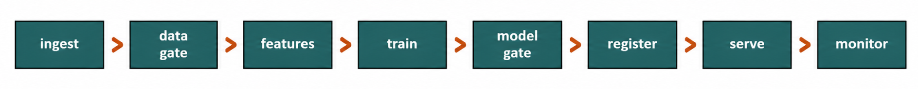
The system is a chain of re-runnable stages. The flow below matches the orchestration code exactly, and every component maps to a stage of the MLOps lifecycle and to a concrete module in the repository.

Architecture component | Lifecycle stage | Repository location
YAML config and loader | problem framing, configuration | config/, src/config_loader.py
Ingest | data collection | src/stages/ingest.py
Data gate | data validation | src/stages/validate_data.py
Feature build | feature engineering | src/features.py
Train | training and tuning | src/stages/train.py
Model gate | model validation | src/stages/evaluate.py
Register and promote | registry and release | src/stages/register.py
FastAPI service | deployment and serving | src/serving/app.py
Monitor | monitoring and drift | src/stages/monitor.py
Prefect flows | orchestration | src/pipeline.py
GitHub Actions | CI and delivery | .github/workflows/

Tools, and the one substitution
Purpose | Tool used | Replaces (AWS)
Tracking and registry | MLflow | SageMaker Experiments and Registry
Orchestration | Prefect | Step Functions, SageMaker Pipelines
Versioning | Git, GitHub, DVC | CodeCommit
CI and delivery | GitHub Actions, pytest | CodePipeline, CodeDeploy
Packaging | Docker | not applicable
Monitoring | Prometheus, Grafana, PSI | CloudWatch, Model Monitor
Configuration | YAML with PyYAML | not applicable

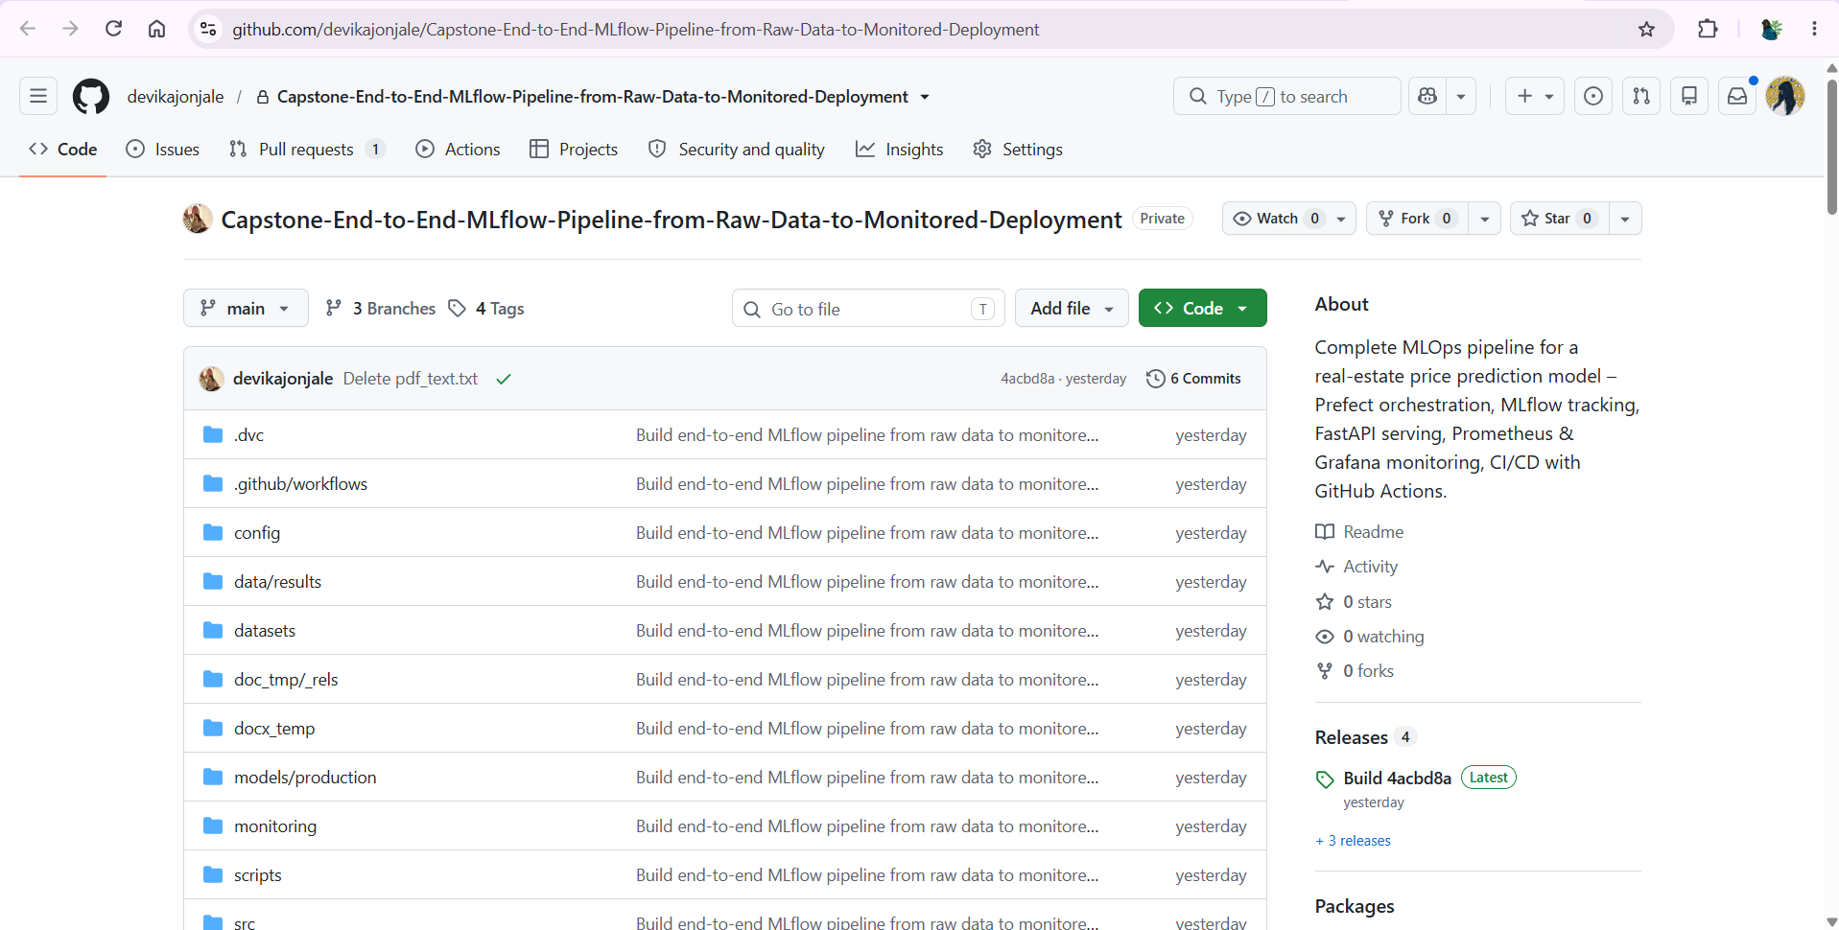
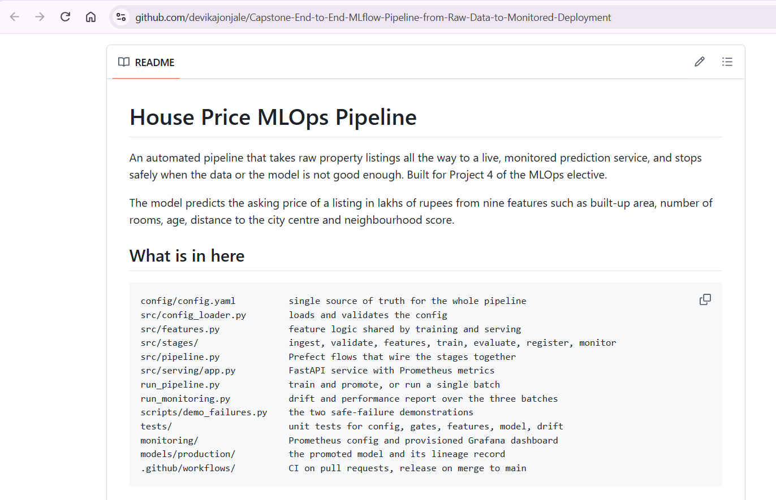
The brief suggests Evidently for drift. We instead compute the Population Stability Index ourselves. PSI is transparent, needs no heavy dependency, runs quickly and is easy to explain live. Because the incoming batches carry the true price, we also measure performance drift directly, which is stronger evidence than input drift alone. The brief allows an equivalent free tool when the choice is justified.
Environment
Python 3.11, with pinned versions in requirements.txt: pandas 3.0, numpy 2.4, scikit-learn 1.8, MLflow 3.17, Prefect 3.9, FastAPI 0.150. Pinning is what makes the results reproducible on another machine.

03 Configuration, Code and Data Management
Reproducibility is a first class requirement, so the pipeline is built around a single source of truth. One file, config/config.yaml, holds every path, threshold and hyperparameter. Nothing is hard coded in the source; each stage reads what it needs from this configuration, and the loader validates it the moment it is read, so a broken config fails immediately rather than halfway through a run.
config/config.yaml (excerpt)
model_gate:
max_rmse: 18.0 # absolute quality bar
max_mae: 13.0
min_r2: 0.65
rmse_tolerance: 0.5 # how much worse than production is tolerated
monitoring:
psi_warn: 0.10 # moderate shift, watch
psi_alert: 0.20 # material shift, raise an alert
performance_alert_ratio: 1.25
Code lives on GitHub. The two datasets are version controlled in the repository, and DVC is configured with a local remote for when the data grows too large for Git. Independently, the training stage records a short SHA256 hash of the exact training matrix on every MLflow run, so a run is tied to the precise data it saw even when the file name does not change. With the seed and hyperparameters fixed and the data hash logged, a clone that installs the pinned requirements reproduces the reported metrics within a small tolerance.

04 The Data
Two datasets are supplied & used as given. The training file holds 4,000 historical listings with prices & incoming file holds 1,500 later listings in three batches of 500 each, used to simulate new data arriving in production.

Data dictionary
Column | Type | Description
House_ID | string | unique listing identifier, not a feature
Batch | int | batch number in the incoming file, not a feature
Area_sqft | int | built up area in square feet
Bedrooms | int | number of bedrooms
Bathrooms | int | number of bathrooms
Age_Years | int | age of the property in years
Distance_to_Center_km | float | distance to the city centre in km
Neighborhood_Score | float | neighbourhood quality score, 1 to 10
Has_Parking | int (0/1) | 1 if parking is available
Property_Condition | category | Poor, Fair, Good, Excellent
City_Zone | category | North, South, East, West, Central
Price_Lakhs | float | TARGET: asking price in lakhs

Data quality and how the batches drift
Three columns, Age_Years, Neighborhood_Score and Distance_to_Center_km, are about four percent missing each, within the ten percent limit the data gate enforces. The incoming batches are not guaranteed to resemble the training data, and discovering how they differ is the heart of the monitoring task. The means below show the shift at a glance.
Quantity (mean) | Train | Batch 1 | Batch 2 | Batch 3
Area_sqft | 1150 | 1152 | 1064 | 936
Bedrooms | 2.42 | 2.42 | 2.27 | 2.02
Bathrooms | 1.99 | 1.98 | 1.86 | 1.72
Price_Lakhs | 61.9 | 62.0 | 63.8 | 69.6
Central zone share | typical | typical | typical | elevated

Batch 1 looks like the training data. Batch 2 is slightly smaller and dearer. Batch 3 has noticeably smaller homes, fewer rooms and a strong tilt to the Central zone, yet higher prices, exactly the kind of shift that breaks a model trained on older data. This is why batch 3 later trips both the drift and the performance alerts.

05 Pipeline Design and Orchestration
The pipeline is orchestrated with Prefect in src/pipeline.py. There are two flows. The training flow runs ingestion, the data gate, feature building, training, the model gate and registration. The monitoring flow runs the data gate, then drift and performance monitoring on one incoming batch against the training reference.

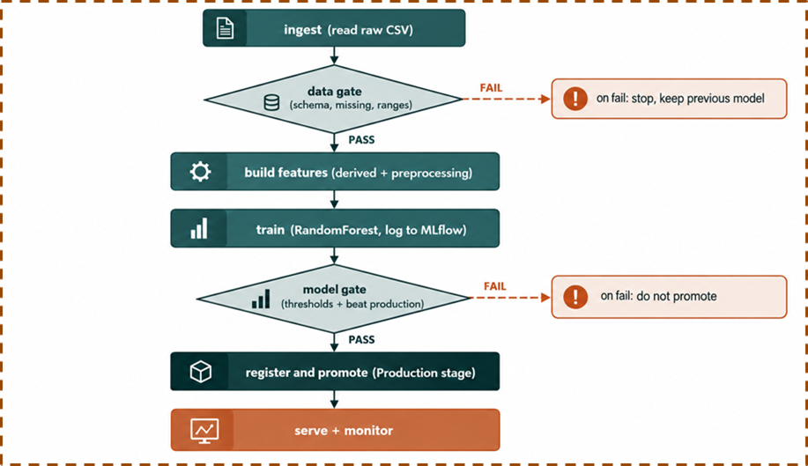
The training flow, drawn

Stage inputs, outputs and re-runnability
Stage | Input | Output | Re-runnable
ingest | raw train path from config | training DataFrame, saved copy | yes
data gate | a DataFrame | pass, or DataValidationError | yes
build features | a DataFrame | feature matrix X and target y | yes
train | X train, y train | fitted pipeline, metrics, run id | yes
model gate | model, X test, y test | metrics and pass or fail | yes
register | model, run id, metrics | registry version, lineage record | yes
monitor | reference, batch, model | PSI, performance ratio, alert | yes

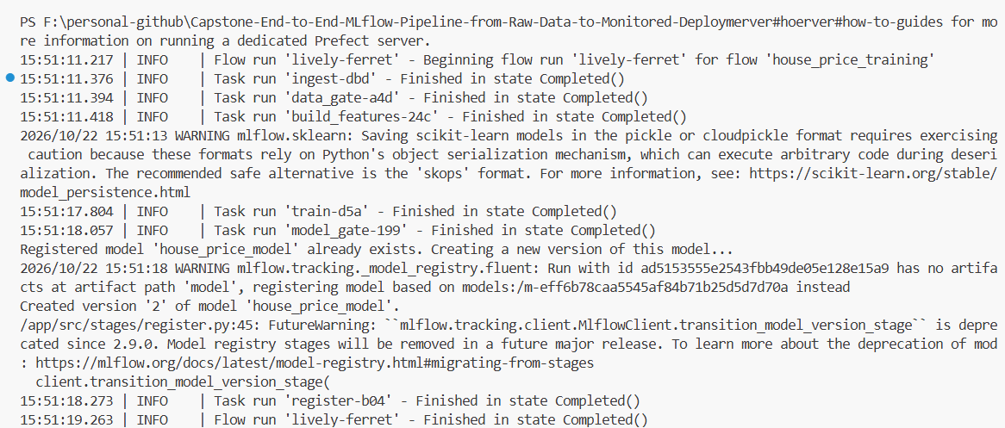
Each stage is a thin Prefect task wrapping a plain function. Prefect records a node per stage with its own logs and run history, while the same plain functions are imported directly to re-run a single stage and by the unit tests. Because stages pass data explicitly and read all settings from the config, any one can be re-run without repeating the whole pipeline.

06 Feature Engineering
Feature logic lives in one place, src/features.py, shared by training & serving. This ensures the model is trained on exactly the columns it later sees at inference time, which avoids a common class of silent production bugs.

Derived features
- rooms_total. bedrooms plus bathrooms, a proxy for usable space.
- area_per_room. area divided by rooms_total, capturing how large the rooms are rather than how many.

Preprocessing built into the model
Imputation, scaling and one hot encoding are not a separate step. They sit inside a single scikit-learn Pipeline with the model, via a ColumnTransformer: numeric columns are median imputed and standardised, categorical columns are most frequent imputed and one hot encoded with unknown categories handled gracefully. Because preprocessing travels with the model as one object, serving only adds the two derived features and calls predict, with no risk of a forgotten transform.

What drives the predicted price
Reading the fitted Random Forest back, the most important features line up with intuition: area dominates, followed by neighbourhood quality, age and distance to the centre. The Central zone flag matters too, which is why batch 3, heavy on Central listings, shifts predictions.
Area_sqft | ██████████████████████████████████ | 34.7%
Neighborhood_Score | ██████████████████ | 18.3%
Age_Years | ████████████ | 12.6%
Distance_to_Center_km | ███████████ | 11.1%
City_Zone = Central | █████████ | 8.9%
area_per_room | ███ | 2.9%
City_Zone = South | ██ | 2.1%
Has_Parking | █ | 1.1%

07 Model Training and Tuning
The model is a Random Forest regressor. It handles the mix of numeric and categorical features well, is robust to the moderate missingness, is not sensitive to scaling and gives a strong baseline without heavy tuning. Its hyperparameters are set in the configuration, not in code.
Hyperparameter | Value | Reason
n_estimators | 200 | enough trees for a stable estimate at reasonable cost
max_depth | 15 | deep enough to fit, shallow enough to limit overfitting
min_samples_split | 5 | avoids splitting on very small groups
min_samples_leaf | 2 | stops leaves memorising single listings
random_state | 42 | fixed seed for reproducibility

Training splits the data into a training portion and an untouched holdout using the seed and test size from the config, fits the pipeline, and logs it to MLflow with its parameters, holdout metrics, the data hash and the config version. The run below is the one currently in production.
training run output
$ python run_pipeline.py
{
"stage_reached": "register",
"n_rows": 4000,
"data_gate": "passed",
"run_id": "38803890a23f49829019cedb76c10bd3",
"holdout_metrics": {"rmse": 9.59, "mae": 7.52, "r2": 0.81},
"model_gate": "passed",
"registered_version": 1,
"status": "success"
}
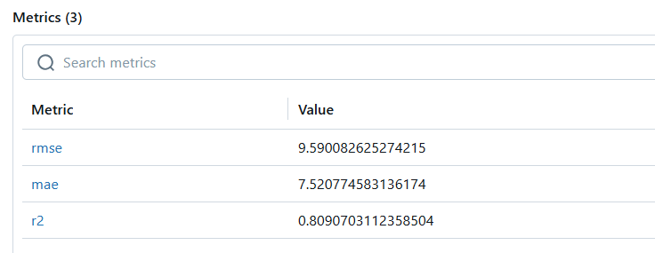
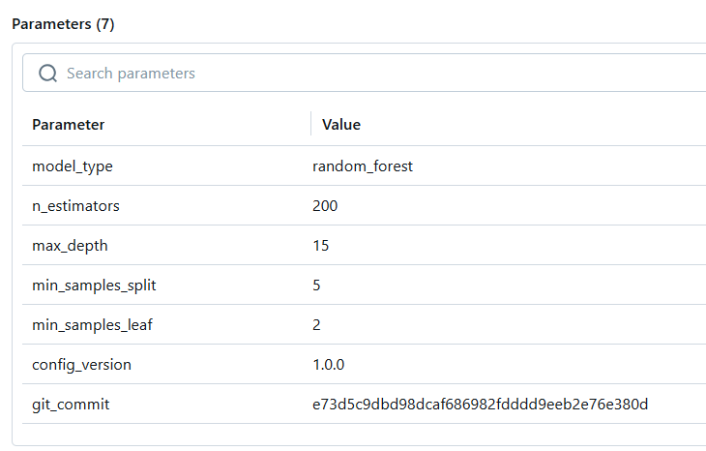

08 Validation Gates and Safe Failure

The data gate
The data gate checks three things against the config: every required column is present, no column exceeds the ten percent missing limit, and every value lies within its allowed range. A batch that breaks any rule is rejected before it can reach the model.
Column | Allowed range
Area_sqft | 100 to 5000
Bedrooms | 1 to 10
Bathrooms | 1 to 10
Age_Years | 0 to 150
Distance_to_Center_km | 0 to 100
Neighborhood_Score | 1 to 10
Has_Parking | 0 to 1

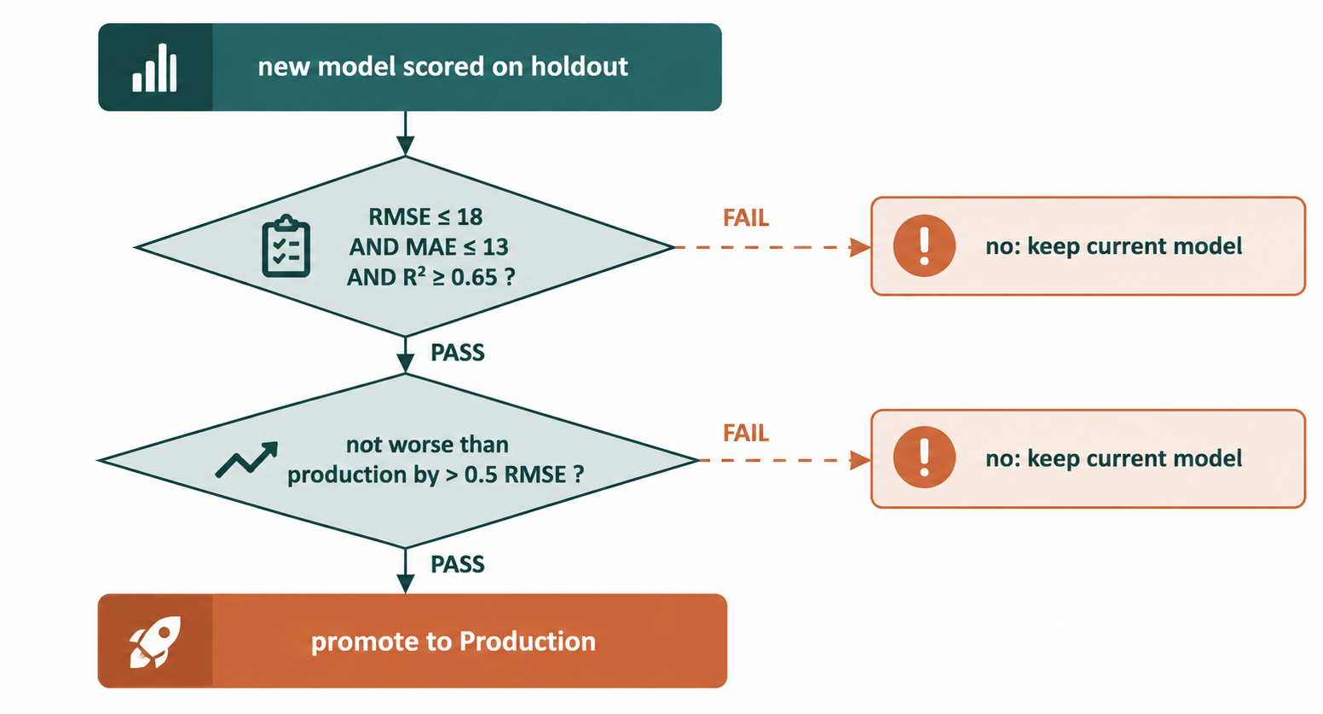
The model gate, as a decision.

Two demonstrated failures (real output)
The script scripts/demo_failures.py exercises both gates and prints the production version before and after, proving the deployed model is untouched.
failure scenarios
$ python -m scripts.demo_failures
=== Scenario A: bad data batch ===
status: rejected | data_gate: failed
reason: Column Area_sqft has a value below the minimum of 100
production version before=1 after=1

=== Scenario B: model below the quality bar ===
status: failed_safe | model_gate: failed
reasons: ['RMSE 9.59 over limit 1.0', 'R2 0.809 under floor 0.999']
production version before=1 after=1
Result
In both runs the production model stayed at version 1 and the service kept answering. Safe failure is the single most important behaviour in the system.

09 Tracking, Registry and Lineage
Every training run is logged to MLflow with its parameters, metrics, data hash and config version. The model is registered and moved to the Production stage only through the register stage of the pipeline, never by hand, which satisfies the rule that only the pipeline may change the production model.

Lineage from the deployed model
Alongside the registry entry, the pipeline writes a self contained lineage record to models/production/lineage.json, also served at the /lineage endpoint. Starting from the deployed model, a reviewer recovers the run id, git commit, config version and holdout metrics, tying the live service back to the exact run, data and code that produced it.
models/production/lineage.json
{
"model_name": "house_price_model",
"registry_version": 1,
"mlflow_run_id": "38803890a23f49829019cedb76c10bd3",
"git_commit": "e73d5c9...",
"config_version": "1.0.0",
"holdout_metrics": {"rmse": 9.59, "mae": 7.52, "r2": 0.81}
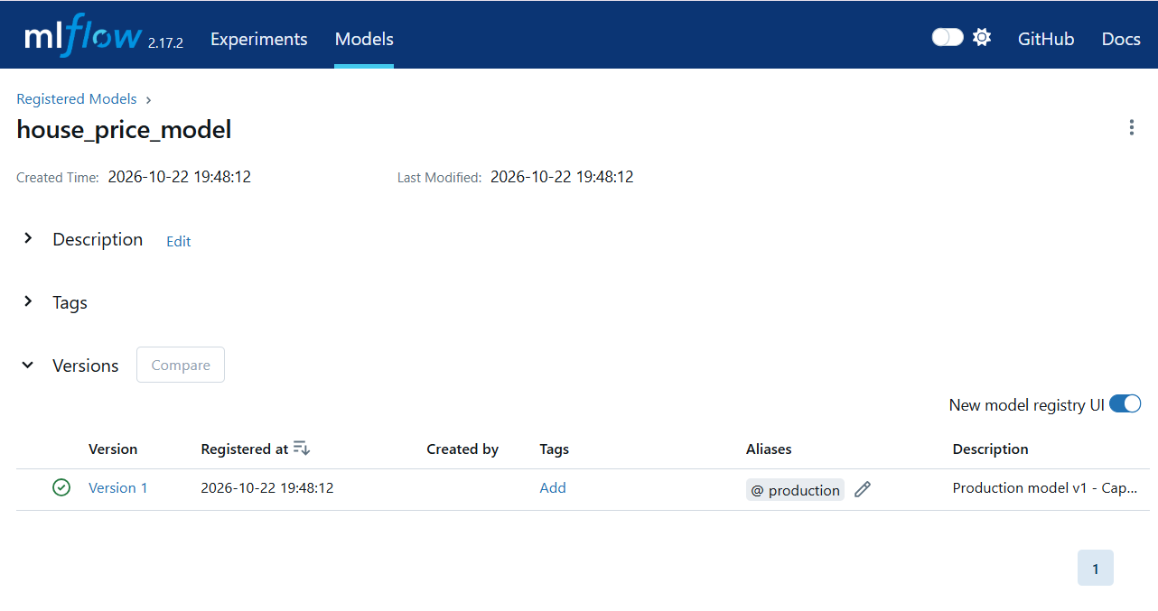
}

10 Serving the Model
The production model is served as a containerised FastAPI application. It loads the self contained pipeline from the committed production folder, so the container scores listings without a running MLflow server.
Endpoint | Method | Purpose
/health | GET | readiness, reports whether the model is loaded
/predict | POST | score one listing, returns the predicted price
/lineage | GET | the deployed model lineage record
/metrics | GET | Prometheus metrics for scraping

A worked request and response:
prediction request
$ curl -X POST http://localhost:8000/predict -H "Content-Type: application/json" \
-d '{"Area_sqft":1200,"Bedrooms":3,"Bathrooms":2,"Age_Years":10,
"Distance_to_Center_km":5.0,"Neighborhood_Score":8.0,
"Has_Parking":1,"Property_Condition":"Good","City_Zone":"North"}'

{"predicted_price_lakhs": 73.42}
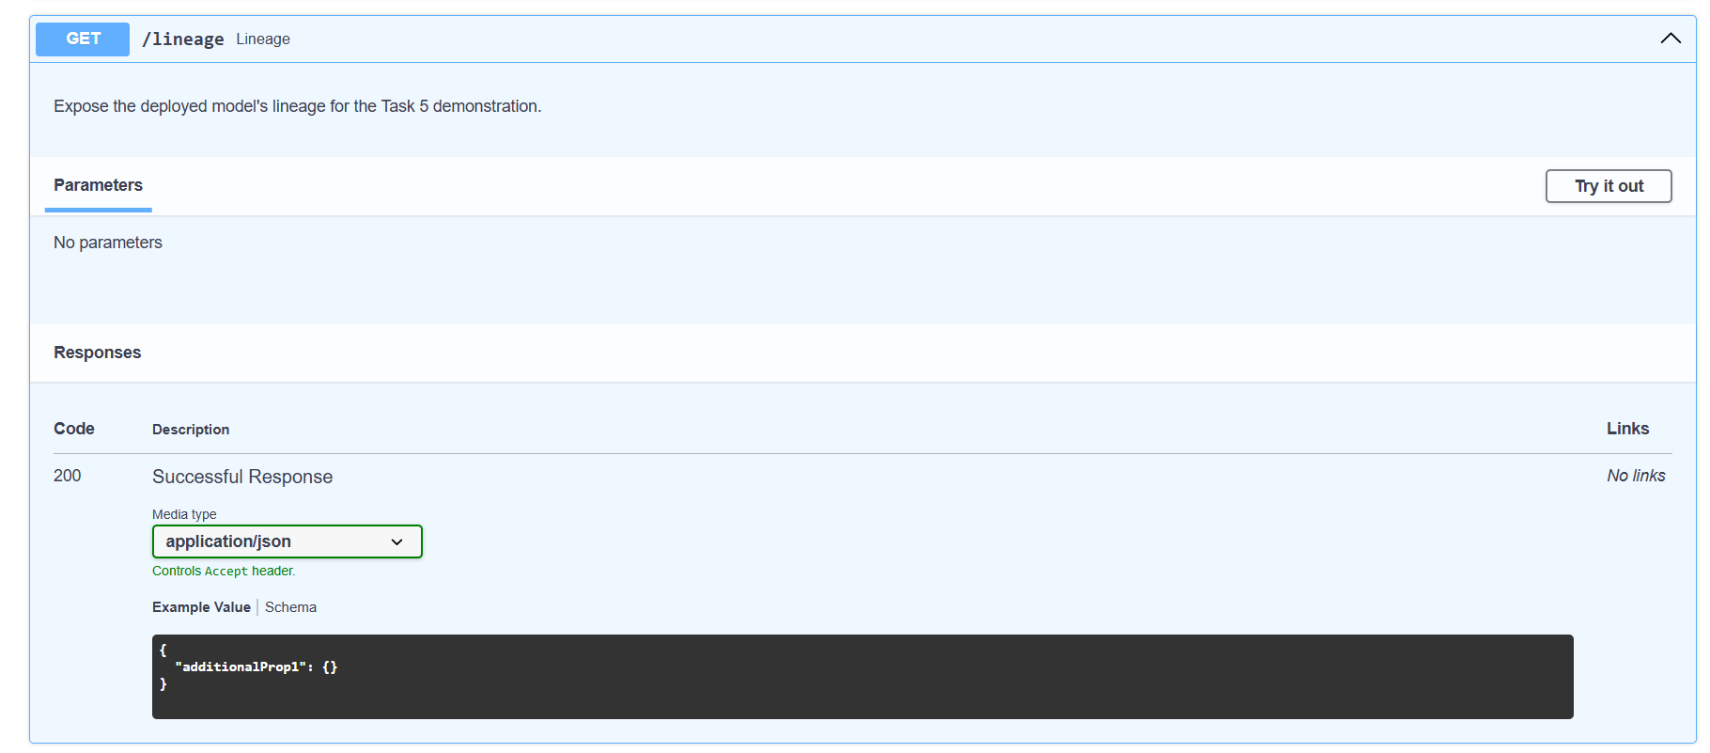
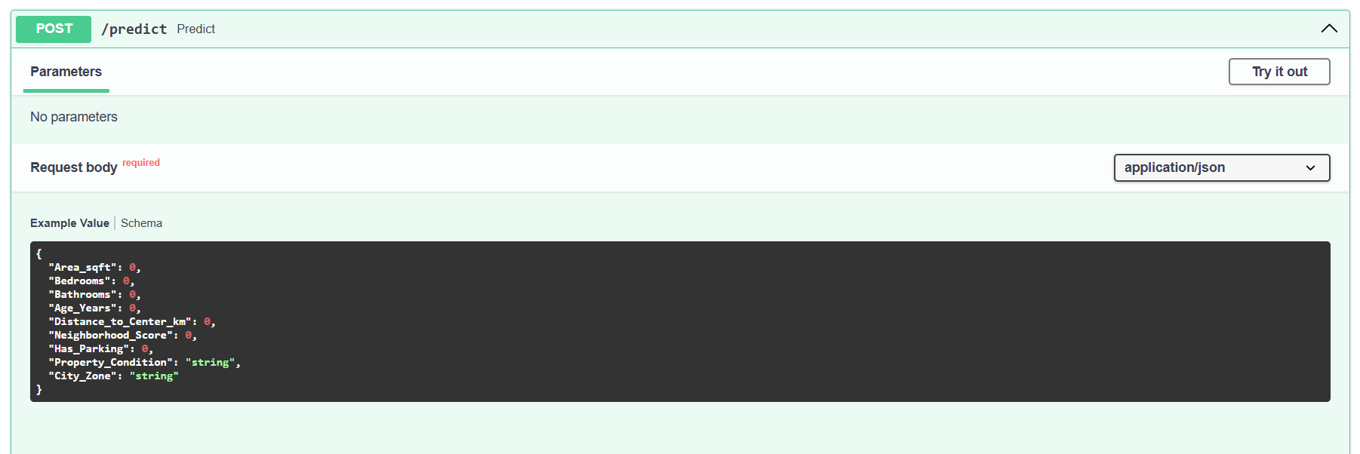
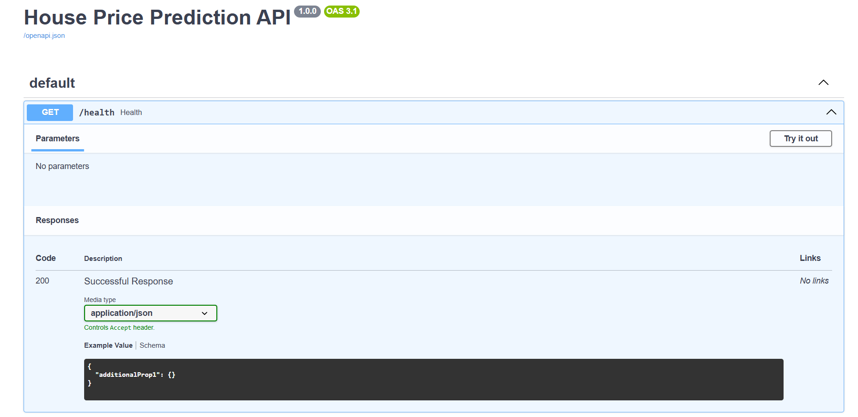
The /metrics endpoint publishes a request counter, an error counter, a latency histogram and a histogram of predicted prices, the signals Prometheus scrapes and Grafana shows.
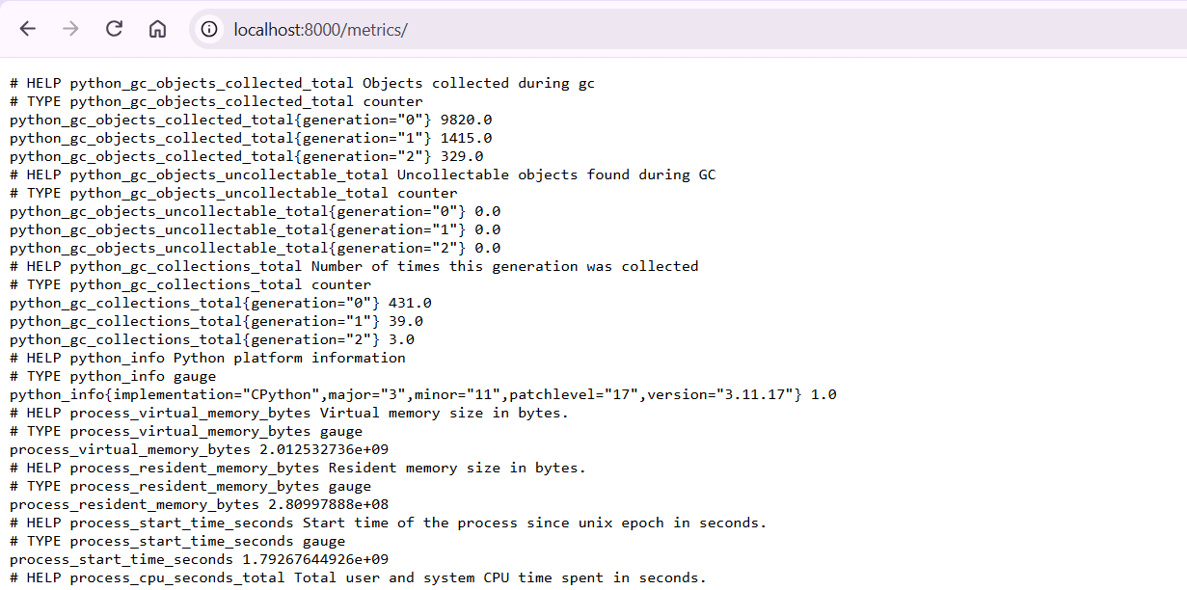
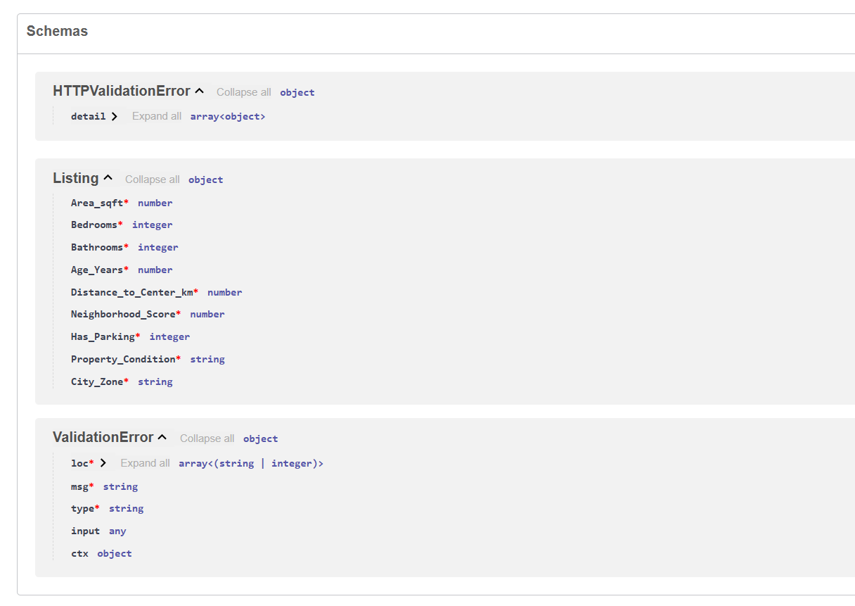
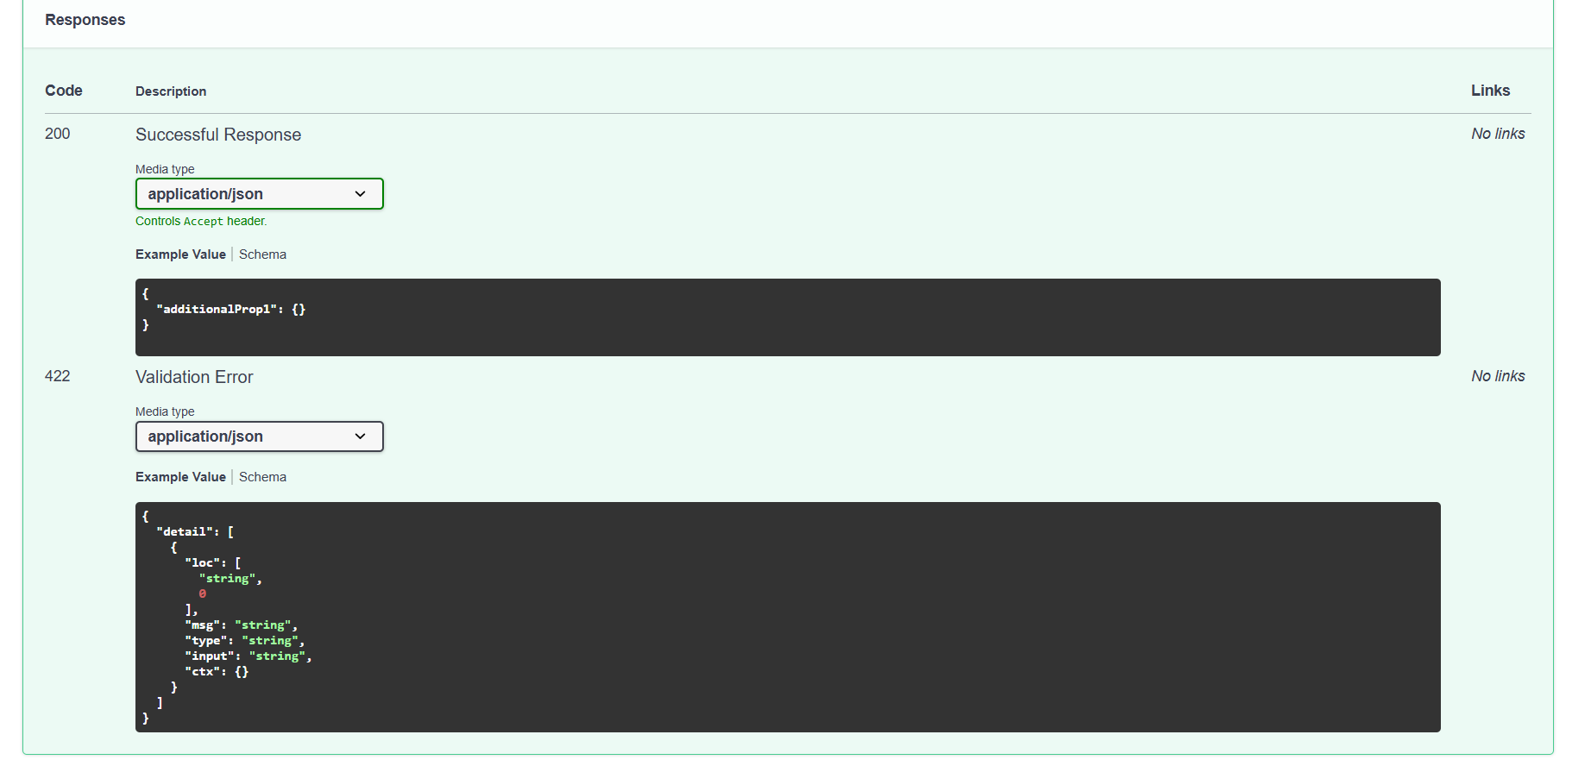

11 Monitoring and Drift Detection
Monitoring answers two questions per batch: has the input data shifted, and has the model actually become less accurate. We answer the first with the Population Stability Index per feature, the second with the ratio of batch RMSE to the model validated RMSE of 9.59. PSI below 0.10 is stable, 0.10 to 0.20 is a moderate shift worth watching, above 0.20 is a material shift that raises an alert.

Per feature PSI over the three batches
Feature | Batch 1 | Batch 2 | Batch 3 | Batch 3 status
Area_sqft | 0.021 | 0.076 | 0.318 | ALERT
Bedrooms | 0.003 | 0.027 | 0.201 | ALERT
City_Zone | 0.001 | 0.027 | 0.206 | ALERT
Bathrooms | 0.001 | 0.024 | 0.104 | watch
Neighborhood_Score | 0.018 | 0.014 | 0.026 | stable
Distance_to_Center_km | 0.024 | 0.029 | 0.019 | stable
Age_Years | 0.011 | 0.015 | 0.006 | stable
Property_Condition | 0.005 | 0.018 | 0.019 | stable
Has_Parking | 0.000 | 0.000 | 0.000 | stable

Batch 3 feature drift, drawn against the 0.20 alert line:
Area_sqft | ██████████████████████████████████ | 0.318
City_Zone | ██████████████████████ | 0.206
Bedrooms | █████████████████████ | 0.201
Bathrooms | ███████████ | 0.104
Neighborhood_Score | ███ | 0.026
alert line = 0.20 | █████████████████████ | 0.200

Performance drift and the alert decision
Batch | Rows | Batch RMSE | RMSE ratio | Drifted features | Alert
Batch 1 | 500 | 9.81 | 1.02 | none | no
Batch 2 | 500 | 11.26 | 1.17 | none | no
Batch 3 | 500 | 18.08 | 1.88 | Area_sqft, Bedrooms, City_Zone | yes

What happens when an alert fires
An alert never changes production by itself. The response is to hold the current model, inspect the cause, and retrain only if the new model passes the model gate. This closes the loop safely.

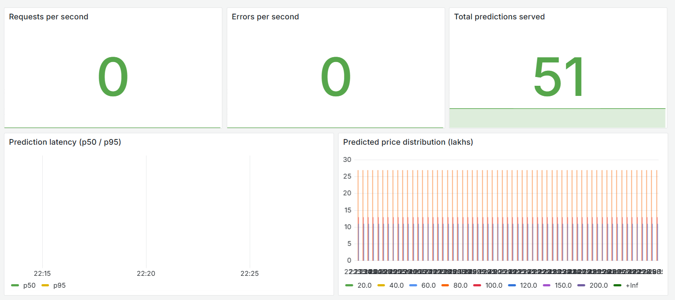
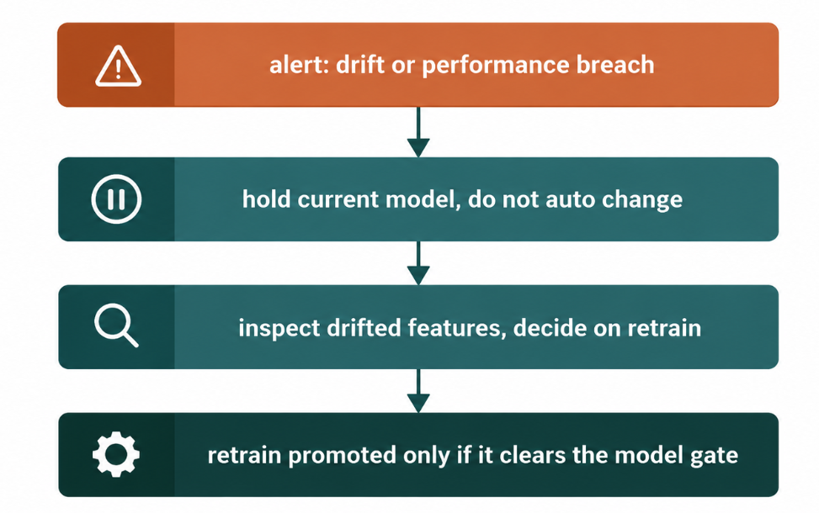
The Grafana House Price API dashboard after sending traffic, showing request rate, error rate, latency and the predicted price distribution:

12 CI, Release and Rollback

Pull request checks
The CI workflow runs on every pull request: it installs the pinned dependencies, runs the full test suite, runs a lightweight end to end pipeline run and builds the serving image. A pull request that breaks any of these shows a red check and is blocked; a passing one shows green. Both outcomes appear in the Actions history, which is the passing and failing pull request evidence the brief asks for.

Release on merge
On a merge to main the release workflow builds a deployable image, tags it with the commit SHA and labels it with the same commit, and publishes a GitHub Release with the image tarball attached. Because the image carries the commit as a tag and a label, any running container can be traced back to its exact source.

Rollback
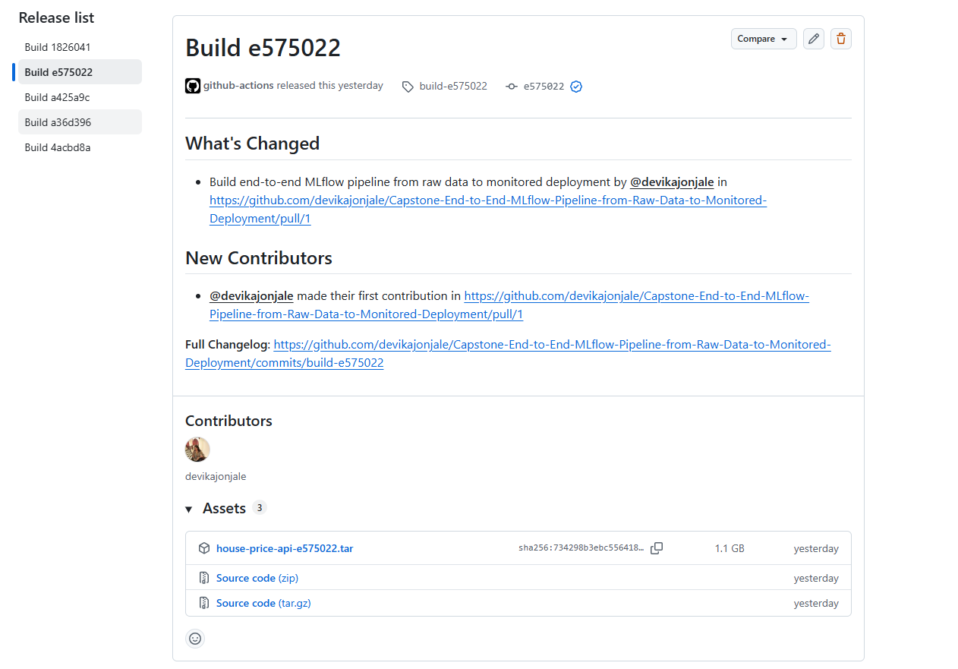
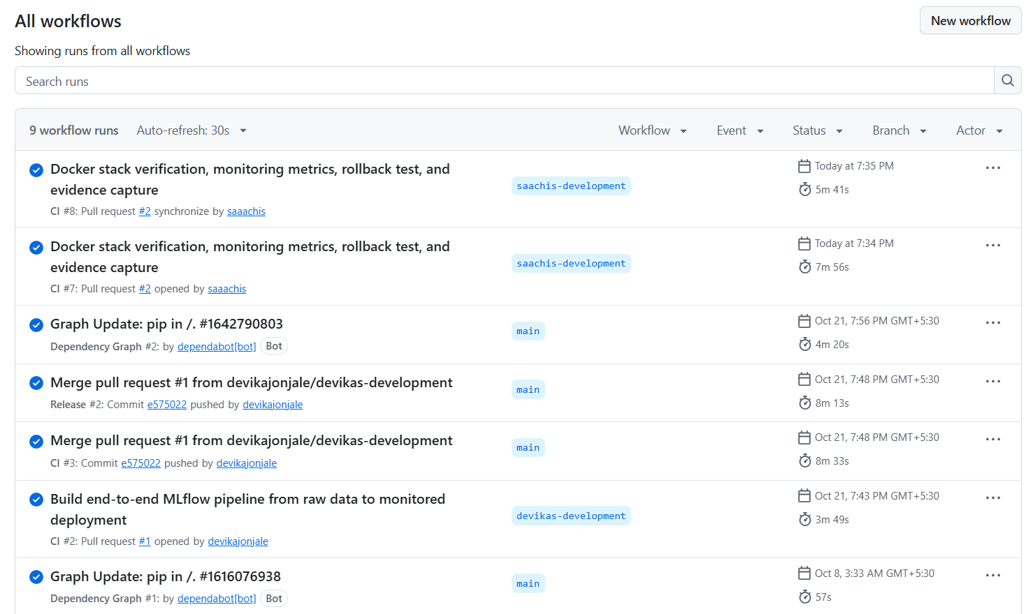
Rolling back means redeploying the image from a previous release: download the tarball from the last good release, load it into Docker, and bring the service back up. The /lineage endpoint then confirms which commit and model version is serving. Because the registry is only ever changed by the pipeline, a service rollback does not disturb the registry. The procedure is written and tested in ROLLBACK.md.
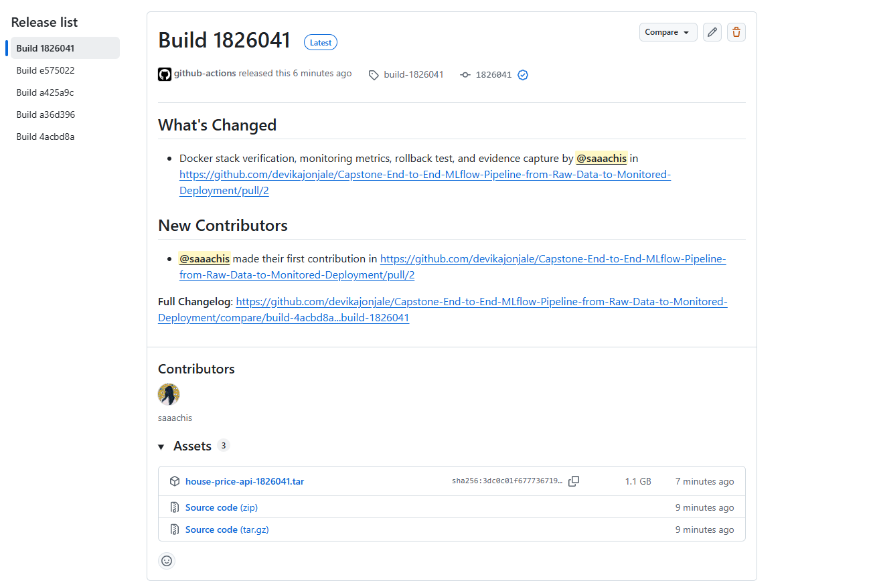

13 Containerised Deployment and Dashboards
The full stack is defined in docker-compose.yml and comes up with one command. Grafana is provisioned routinely with the Prometheus data source and the House Price API dashboard, so there is nothing to click over.
Service | Port | Purpose
app | 8000 | the FastAPI prediction service
prometheus | 9090 | scrapes the service metrics every ten seconds
grafana | 3000 | dashboard, admin and admin
mlflow | 5000 | tracking and registry user interface

How the stack connects
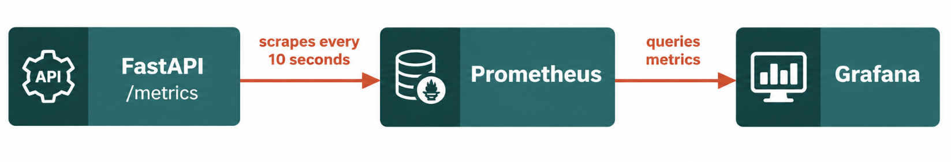
Prometheus scrapes the service every ten seconds; Grafana queries Prometheus. The dashboard shows request rate, error rate, latency percentiles and the predicted price distribution. Recreating the dashboard by hand and adding live alert rules are documented in GRAFANA_SETUP.md, while full container orchestration and verification procedures are maintained in the repository deployment documentation.
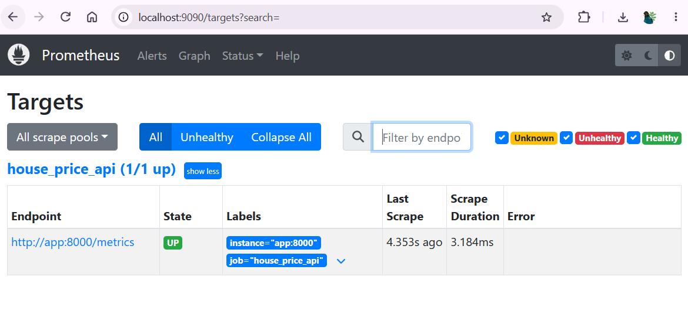
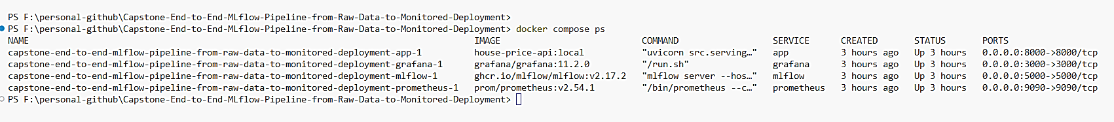

14 Worked Example: One Full Run
This section walks through a single, complete use of the system, the way it would be used when a new batch of listings arrives. It is the story the live demonstration follows.

Step 1. Train and promote the first model
With a clean clone and the requirements installed, one command trains the model, runs both gates and promotes the result. The data gate passes on the 4,000 training rows, the model clears the quality bar, and version 1 is registered to Production.

$ python run_pipeline.py
... data_gate: passed ... model_gate: passed
"registered_version": 1, "status": "success"

Step 2. Serve a quote
The service loads the promoted pipeline and answers a quote for a three bedroom listing in the North zone.
$ curl -X POST localhost:8000/predict -d '{...listing...}'
{"predicted_price_lakhs": 73.42}

Step 3. New batches arrive and are monitored
Running monitoring over the three incoming batches produces the report below. Batches 1 and 2 pass quietly; batch 3 trips the alert.
$ python run_monitoring.py
| Batch | Drifted features | RMSE | Alert |
| batch_1 | none | 9.81 | no |
| batch_2 | none | 11.26 | no |
| batch_3 | Area_sqft, Bedrooms, City_Zone| 18.08 | yes |

Step 4. A bad batch is refused
If a batch arrives with impossible values, the data gate refuses it and the production model keeps serving, unchanged.
$ python -m scripts.demo_failures
status: rejected | data_gate: failed
production version before=1 after=1

Step 5. Ship a change safely
A code change opens a pull request, which CI tests and runs. On merge to main a release builds an image tagged with the commit, and if anything goes wrong the previous image is reloaded per ROLLBACK.md. At no point does anything other than the pipeline change the production model.
Demonstration script
This end to end loop, a code change through CI, a pipeline run, deployment, a monitoring update and one safe failure, is exactly the 5 to 10 minute demonstration the brief asks for.

15 Results, Contributions and Reflection

Rubric coverage
Rubric criterion | Marks | Where it is met
Problem framing and design | 10 | Sections 01 and 02, justified thresholds
Pipeline architecture and orchestration | 20 | Section 05, Prefect flows, re-runnable stages
Gates and failure handling | 15 | Section 08, two demonstrated failures
Tracking, registry and lineage | 15 | Section 09, MLflow, registry, /lineage
CI/CD and release | 15 | Section 12, ci.yml, release.yml, ROLLBACK.md
Deployment and monitoring | 20 | Sections 10, 11, 13, metrics, drift, Grafana
Demonstration and documentation | 5 | Section 14, README, this report

Individual contributions
Devika Jonjale (B045) was responsible for pipeline architecture, model development, automated quality gates, and lineage tracking. She designed the centralized configuration framework (config.yaml) and orchestrated the modular training and monitoring flows using Prefect.
She implemented the dual-gate governance mechanism: the Data Gate for schema and boundary validation, and the Model Gate to prevent regressions before deployment. Devika engineered the preprocessing and Random Forest training pipeline, integrated MLflow for experiment tracking and Model Registry promotion with cryptographic data versioning, built the PSI drift detection module, and developed the automated test suite ensuring deterministic, safe-failure behavior.
Saachi Shinde (B048) was responsible for containerisation, operational monitoring, disaster-recovery verification, and release engineering. She authored the multi-service Docker Compose architecture (app, prometheus, grafana, mlflow), verified live model serving endpoints (/health, /lineage, /predict, /metrics), simulated synthetic listing traffic, and validated real-time metrics flow into Prometheus and the auto-provisioned Grafana dashboard.
She executed and documented the disaster-recovery rollback procedure per ROLLBACK.md, authored and merged Pull Request #2 to trigger the automated GitHub Actions CI/CD release workflow (Build 1826041), and compiled the final technical evidence and reporting.

Reflection: what we would improve with more time
The pipeline does what the brief asks, but a few things would make it sturdier. We would add automatic retraining triggered by a drift alert, gated the same way, so the loop closes without a person in the middle. We would push serving metrics and batch drift scores into the same Grafana instance and add live alert rules rather than only the batch report. We would move the MLflow backend from a local SQLite file to a shared server so runs from CI and distributed development environments land in one place. We would widen the tests with a property based check on the feature logic and a contract test on the serving schema. Finally we would add a small, logged hyperparameter search instead of the hand chosen values.

Reproducibility
To reproduce: create a Python 3.11 virtual environment, install the pinned requirements, run pytest, then run_pipeline.py and run_monitoring.py. The docker compose stack reproduces the full serving and monitoring environment. All tools are free and open source and no secrets are stored in the repository.

Conclusion:
The Capstone End-to-End MLOps Pipeline has been fully implemented, integrated, and verified against all criteria in the project brief. From raw data ingestion, automated quality gating, and reproducible model training to MLflow lineage tracking, containerised FastAPI serving, Prometheus/Grafana real-time monitoring, and zero-downtime rollback recovery, every architectural layer operates deterministically. Automated gates prevent invalid data or sub-par models from reaching production, while GitHub Actions CI/CD ensures that every release is cryptographically tied to its source commit.

The complete system was successfully executed, stress-tested, and validated in an isolated multi-container Docker environment, providing a robust, production-grade template for reliable ML deployments.

***

